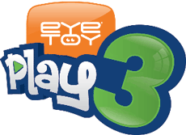
<5th September 2005>
For Immediate Release

The secret is out… the PlayRoom content for EyeToy®: Play 3 is uncovered
- Get up to mayhem in the Laboratory and the Fun zone
- Uncover hidden secrets with the Recog-cam™
- On sale in time for Christmas

News Flash: EyeToy®: Play 3 just got zanier with the announcement today of the contents of the new PlayRoom feature from Sony Computer Entertainment Europe. The PlayRoom pushes the boundaries of creativity to deliver two new areas where players can get up to all kinds of crazy antics using the EyeToy® USB Camera.

The two new PlayRoom areas have been aptly named the Laboratory and the Fun zone – each containing an eclectic mix of weird and wonderful games to capture the imagination. Games in the Laboratory are:

- The Face Mixer Machine: Discover what you and your friend’s faces would look like if they were mixed together – the clever machine takes pictures of faces via the EyeToy USB Camera and then mixes them together for hilarious results.

- The Head Swap: This unusual game lets players see what their head would look like with their friend’s body - just make sure you don’t walk off with the wrong one!

- The Photo Booth: No more queuing for the photo booth. With this new game, players can have hours of fun taking silly snaps with their friends and images can be saved forever using a supported USB mass storage device.

Enter the Fun zone for the following treats:

- Theremin: This audio treat translates your movements into different sounds allowing you to change the pitch by moving your arms around.

- Vs Knockout: Play against your friends in an unusual game of back-to-front kung fu.

- Wild Fauna: Get closer to nature with this peculiar game that turns rooms into woodland paradises – watch the trees and plants grow before your very eyes, but shusssssh… keep still and quiet, or you might scare the animals…

- Motion-Cam™: All the old favourites are back as the Motion-Cam section contains the most popular effects from EyeToy: Play and EyeToy: Play 2. With Copy Cat, Paint, Mirrors, Materialise Effects and much more you can while away the hours with the very best that EyeToy has to offer.

And on top of all of this, EyeToy: Play 3 also features the exclusive Recog-Cam™. A ground breaking system reveals secret content hidden in the game, all you have to do is hold one of the images attached to this press release in front of the EyeToy USB Camera whilst in the PlayRoom and the hidden extras will be released - there has never been anything quite like this before!

Whether you are a laboratory lover or a fun zone fanatic, play the day away in the EyeToy: Play 3 PlayRoom, on shelves from November.

- Ends-

About Sony Computer Entertainment Europe Ltd.
Sony Computer Entertainment Europe (SCEE), based in London, is responsible for the distribution, marketing and sales of PS one®, PlayStation®2 and PlayStation® Portable software and hardware in 104 territories across Europe, the Middle East, Africa and Oceania. SCEE also develops, publishes, markets and distributes games software for the three formats, and manages the third party licensing programs for these platforms in the PAL territories. At the end of June 2005, over 40 million PlayStation® units had been shipped across these PAL territories, over 102 million worldwide. Between its European debut on 24 November 2000 and 20th July 2005, over 33 million PlayStation®2 units have been shipped across the PAL territories, over 91 million world-wide, making it one of the most successful consumer electronic products in history. Between the launch of the PSP in Japan in December 2004 and 21 July 2005, over 5 million PSPs have been shipped worldwide.

PlayStation and the PlayStation logo, PS one and PS2 are registered trademarks of Sony Computer Entertainment Inc. PSP and UMD (Universal Media Disc) are trademarks of Sony Computer Entertainment Inc. All other trademarks are property of their respective owners.

More information about PlayStation products can be found at http://www.scee.com , www.yourpsp.com , www.eyetoy.com and www.playstation.com. or visit the Virtual Press Office at www.scee.presscentre.com.

EyeToy®: Play 3 ©2003-2005 Sony Computer Entertainment Europe. Published by Sony Computer Entertainment Europe. Developed by London Studio. EyeToy is a registered trademark of Sony Computer Entertainment Europe. All rights reserved.

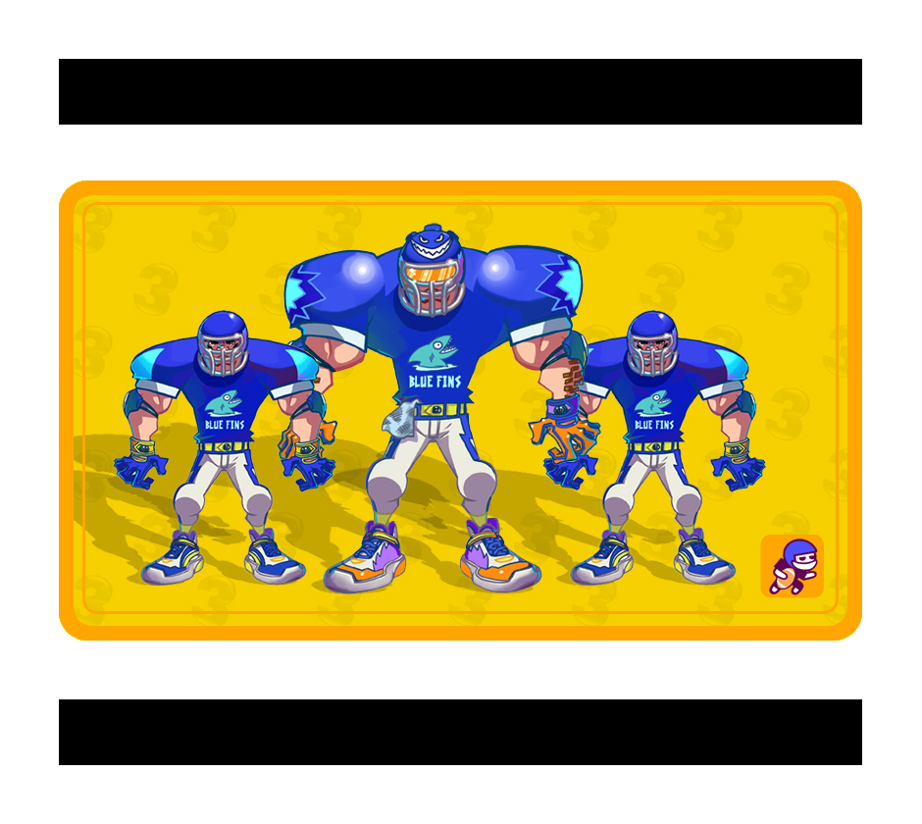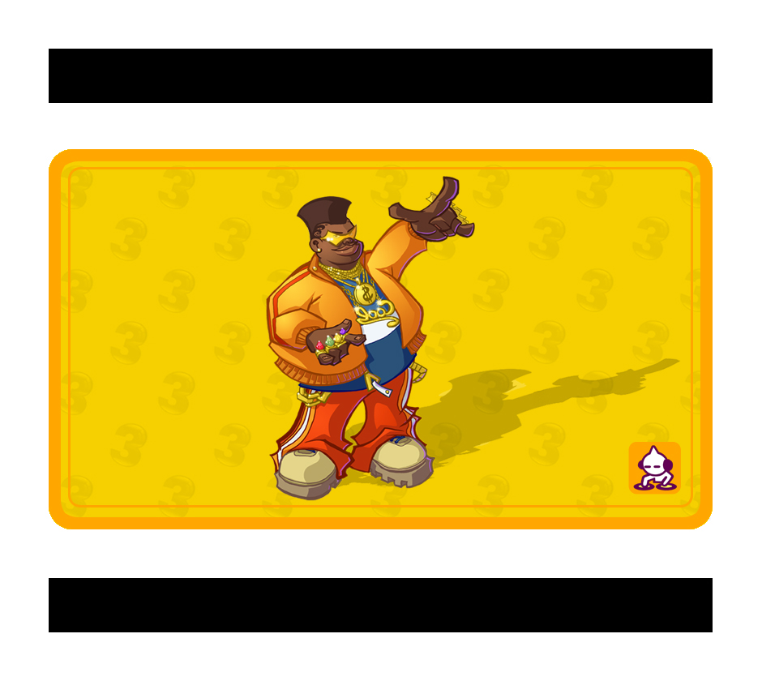

Print these cards out preferably using a high quality colour or black and white printer, and then hold the images up to the EyeToy USB Camera (for PlayStation®2) whilst in the PlayRoom of EyeToy: Play 3 to unlock hidden secrets.

